**The American University in Cairo**

**Computer Science and Engineering Department**

**Fundamentals of Computing II**

**Fall 2020**

**Pacman Milestone I**

**Note: you are only required to deliver Milestone 1 requirements described at the end of this document.**

1. Overview

It is required to Implement a graph-based Pacman, learn more [**here**](https://en.wikipedia.org/wiki/Pac-Man) and play it [**here**](https://www.google.com/logos/2010/pacman10-i.html), where the player explores Pac-Man through a maze. This maze is loaded up with Pac-Dots (pellets) and incorporates three wandering multi-hued ghosts: Blinky, Pinky, Inky, and Clyde.

The goal of the game is for Pacman to collect all of the pellets (dots) in the maze. Once the player has collected all of the pellets, the player has won.

There are 4 ghosts that will make it difficult for the player to collect all of the pellets. They will chase the player in various ways and if the player comes into contact with any of the ghosts, the player will die (lose a life). When the player loses all of his lives, the game is over.

There are 4 power pellets and if the player eats any of these power pellets, then the player can eat the ghosts. When the ghosts get eaten, they will respawn in their original location.

There are also fruits that periodically appear in the maze for Pacman. If Pacman eats them, he collects additional points [***Bonus***].

1. Game Specifications

Initial State:

* The player starts with three lives, yet the player will get one additional life reward subsequent to acquiring 10,000 points.
* The game starts off in a paused state. The words "Ready" appear just below the ghost home. When the user is ready to start the game he presses the spacebar.
* The three ghosts start in the ghost home which is always located in the middle of the maze.
* Inside the ghost home the ghosts are from left to right Inky, Pinky, and Clyde.

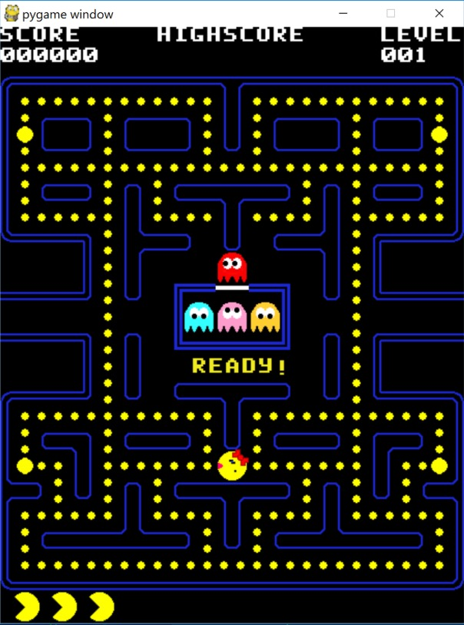

* When the game starts the ghosts leave their home and they wander in different directions.
* Close to the edges of the maze are four power pellets that permit Pac-Man to eat the ghosts and gain extra points.

Pellets:

There are two types of pellets: regular pellets and power pellets.

* **Regular pellets** are smaller and the exact number of them will depend on the maze. The original Pacman maze has 240 of these pellets.
* **Power pellets** are larger and each maze will only have four of these pellets usually placed in the four corners of each maze. When Pacman eats a power pellet, he becomes invincible to the ghosts. This lasts for a small period of time of your choosing.

Notes:

* Pacman is controlled by the four arrows to move around the screen. If you hit any key (right for example), pacman will keep moving right until he meets a wall, or the user presses another direction key.
* The maze has portals so that the player can **portal from one side of the screen to the other** side of the screen. The ghosts are also able to use these portals. They are placed at opposite sides of the screen.
* Pacman moves to eat all pellets avoiding the ghosts. When Pacman has eaten all of the pellets including the four power pellets, the player has won.
* If Pacman gets eaten by a ghost, a life is lost and **Pacman and the ghosts return to their initial positions, however, the pellets that are eaten, remain eaten**. When the 3 lives are lost, the player has lost the game.
* The **game ends** if the user eats all pellets or if the 3 lives are lost.
* You can choose the scores you’d like for the game, here is an example:

A score for eating a regular pellet is 10, a power pellet is 50.

Maze Mapping

To create the maze, it should be represented in a text file. When the game starts, it should parse the corresponding text file to the map.

***Design your own format*** that would satisfy the requirements described in this document.

1. A ghost homes
2. The 2 portals.
3. Maze Bricks
4. Pathways for the player and the ghosts to move through, that would contain pellets as well.

Here is an example for how you can use text to generate a simple maze (that will be turned into a graph). Here, -1 represents bricks and numbers are given to the points (rectangles) that are considered the pathways.

1. Project Statement

Build up a 2D game that satisfies the given description. Your game ought to comprise of the accompanying:

● One player. (the Pacman)

● Multiple enemies. (Three ghosts)

● Pickups (regular and power pellets and may increase points, lives, etc.)

1. ***Requirements for Milestone 1***

*Design the main structure of the game*

* Reading the board from a text to the window
* Classes of all the objects needed i.e. You should be able to create objects of the ghosts, pacman and pellets. (*the number and design of the classes is up to you and your understanding of the concepts of OOP*)
* Strings representing the score of the player, the lives left, the mode of the game (normal/invincible) and a win/lose output at the end.

When you run the game, you should have the main layout of pacman with ghosts that ***move randomly*** (no graphs required) and pacman moving with keyboard arrows. Pacman should be able to eat the pellets. And the ghosts should be able to take a life from pacman if they intersected with him.

A win/lose output should be displayed according to the rules described in this document.

**Suggested Workflow:**

1. Create the text file representing the board.
2. Read the text file inside the code and draw the board graphics.
3. Draw the character of the player, i.e. Pacman, and control its movement.
   1. Handle the power pellets mode (Pacman being invincible)
   2. Handle the score of the player.
4. Handle the characteristics of the pellets (when they collide with pacman, they should disappear (as if eaten), when they are all eaten, (a win output would appear).
5. Draw the enemies, i.e. the three ghosts, and control their movement (their movement is based on random directions).
6. Handle the enemies’ collision with Pacman (Each collision results in a life lost, when the three lives are lost a lose output would appear)

**Note: Your board doesn’t have to look like the original pacman game, something as simple as the image below will do the job!**

1. Guidelines

* Plagiarism will not be tolerated.
* Your code should be modular and object oriented.
* Please make your code readable.
* Add comments to your code and choose short and descriptive variable and function names.
* You can seek the help of TAs if you need more clarification, but please make sure to read the document first.

.

Best of luck